BEGINNING OF TERM ONE EXAMINATION 2024
ENGLISH
PRIMARY THREE

My name is ________________________________________________
Class ______________________________________________________
1. Fill in the missing letters.
(a) t__ __cher (b) ch__r__h

2. Write these words correctly.
(a) eepsh _______________ (b) atgo _______________

3. Arrange the words in a, b, c order.
(a) frog, eel, dog, cat
___________________________________________________
(b) zebra, hyena, rat, lion
___________________________________________________

4. Write the following in full.
(a) She’s________________ (b) Tue. ________________

5. Punctuate these sentences correctly.
(a) what is your name
___________________________________________________
(b) I have a book pen and pencil
___________________________________________________
6. Make small words from the big words.
(a) father ___________________________
(b) parent ___________________________

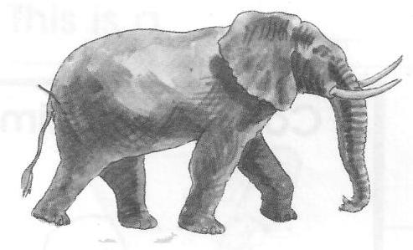
7. Answer correctly. ______________
(a) Is this a table?

______________________________

(b) Are these books?

________________________________

8. Give the opposite of the underlined word.
(a) The classroom is dirty. ____________________
(b) Musa is taller than Jane. ____________________

9. Give the singular form of the word in the brackets.
(a) This ________________ is blunt. (knives)
(b) Our baby has one ________________. (teeth)

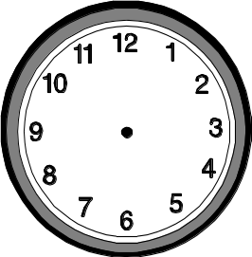
10. Tell the time.
(a) (b)

It is __________________ It is ____________________
11. Complete the table below.

 | heavy | heavier | heaviest
(a) | happy | ______________ | happiest
(b) | short | shorter | ______________
(c) | ______________ | richer | richest

12. Use “has” or “have” to complete the sentence.
(a) Joy ______________ a new dress.
(b) The children _______________ many books.
(c) Do you _______________ money to buy milk?

13. Use the correct form of the words given in brackets.
(a) Sarah is _________________. (dance)
(b) The tree ______________ on the house yesterday. (fall)
(c) The baby _______________ every night. (cry)

14. Choose the word similar in meaning to the one underlined.
(hard, start, right, easy)
(a) The test was difficult. ________________
(b) We can begin writing. _______________
(c) I can give correct answers only. _____________
15. Underline the adjectives in the sentences.
(a) Betty is happier than Mary.
(b) As busy as a bee.
(c) It is very hot today.

16. Use the right word from the brackets.
(a) I know how to ____________ good letters. (right, write)
(b) A _____________ man is eating a rat. (mud, mad)
(c) I am in primary _____________. (too, to, two)

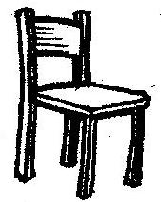
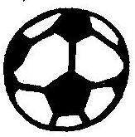
17. Make one sentence about each picture.
(a) ______________________________________
______________________________________
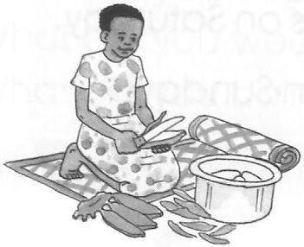
(b) ______________________________________
______________________________________
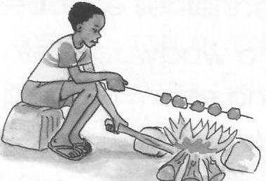
(c) ______________________________________
______________________________________

18. Fill in “hers” “mine” “ours” or “theirs” correctly.
(a) Our ball is black. The black ball is ______________
(b) My skirt is white. The white skirt is ______________
(c) Her cows are here. The cows here are ____________

19. Use “some” or “any” to complete the sentences.
(a) I have ______________ sugar left in the tin.
(b) There isn’t _________________ water in the jerrycan.
(c) Do you have ________________ book left?

20. Re-write as instructed.
(a) Sarah has a pencil. She is not writing. (Join using: ……but……..)
___________________________________________________
(b) Musa came late. Musa was sick.
(Join using: ………...because………..)
___________________________________________________
(c) Boys have rubbers. Girls have rubbers.
(Join using: ……..and………)
___________________________________________________
Good Luck
P.3 English Marking guide B.O.T TERM I 2024
- (a) e a (b) u c
- (a) sheep (b) goat
- (a) cat, dog, eel, frog
(b) hyena, lion, rat, zebra
- (a) She is/has (b) Tuesday
- (a) What is your name?
(b) I have a book, pen and pencil.
- (a) Fat/at/her (b) are/rent/par
- (a) No, it not (b) Yes, they are.
- (a) clean (b) shorter
- (a) knife (b) tooth
- (a) three o’clock
(b) a half past six o’clock
- Happier, shortest, rich
- (a) has (b) have (c) have
- (a) dancing (b) fell (c) cries
- (a) hard (b) start (c) right
- (a) happier (b) busy (c) hot
- (a) write (b) mad (c) two
- (a) The boys are playing football.
(b) The birds are flying over the tree.
(c) The cat is chasing the rat.
- (a) ours (b) mine (c) hers
- (a) some (b) any (c) any
- (a) Sarah has a pencil but she in not writing.
(b) Musa came late because he was sick.
(c) Boys and girls have rubbers.

